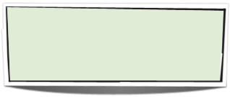

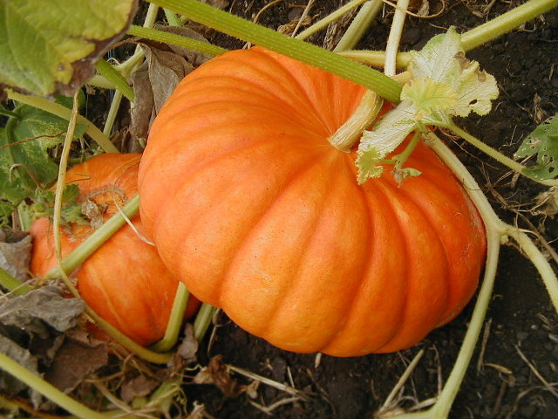
September
A new beginning to a fantastic school year!
The students, and teachers alike, have settled into school. In science we spent the month establishing classroom routines and learning to work together.
We started off the year with the differences between observations and inferences. This will be a skill we will continue to develop all year long. We transitioned into graphing, collecting data and identifying dependent variables, independent variables and control groups.

October
Looking Forward:
This month we will continue to build our science process skills and dive into measurement. These topics are challenging yet useful in science. Ask your child the difference between mass and weight - or - how you can find the volume of an object. Your own personal scientist should be able to answer all of your questions.
Don’t forget to check gradebookwizard.com to keep updated on your child’s grades!

Welcome!

This year in science will be full of discovery, learning, and fun. I’d like to open communication between home and school to insure a successful year for all!

Contact Information

Mrs. McGuire - Science

Email - mrsmcguire.science@gmail.com

Website - http://mrsmcguirescience.weebly.com

Team Website -http://team72.weebly.com

Grade Book - www.gradebookwizard.com

September-October 2011

We soon will be observing (and making inferences) on our classroom pumpkins.

Science Fall News

“School is a building with four walls with tomorrow inside.”

- A Recipe For Life

NECAP

As you know, Woonsocket Middle School is in the final stages of taking the statewide NECAP test.

Our team has put in a lot of effort to prepare for the NECAP. Because our students have shown (and are continuing to show) true dedication, we will be having a team celebration towards the end of the month! There will also be a school-wide celebration that students can participate in. Stay tuned!




Please make sure to check your child’s agenda on a daily basis.
The agenda should come home every night. It is a record of all homework, projects, missing work and daily behaviors. Every day in class the teacher will sign the agenda to make sure the student has written down the homework. If homework is not turned in, a “Homework Not Done” stamp will be put in the agenda. This serves as a reminder for the student to make sure he/she turns it in.
The agenda also serves as a means of communication from school to home. Because the teachers sign the agendas each day, we will see any notes you may write to us and vise versa. Also, if a student should receive detention it will be written in the agenda.

Important Dates to Remember
October | November | December
10th - Columbus Day (no school) | 8th - Election Day (no school)  11th - Veteran’s Day (no school) | 15th - Progress Reports Distributed
7th - Progress Reports Distributed | 17th - Report Cards Distributed | 26th - Jan. 3rd - Winter Vacation
13th - Parent Teacher Conferences | 24-25th - Thanksgiving Recess

Field Trips

We are currently planning field trips for this year. We will possibly be taking the students to the Boston Museum of Science in January. If you would like to chaperone, please let me know!

I would also like to extend an invitation to you to help out in the classroom. If you have anything you would like to share, or would like to volunteer, please let me know and we can work on arranging a time.

Science Materials Needed Each Day

Pen/pencil ~ Science Binder ~ Agenda ~ I.D. ~ Personal Reading Book

